Case Study on Shopping Portal
On xyz.com
Arijit Roy
11/20/2011

Topics | Page No.
Requirement Specification | 3
A few Important Things | 4
Different tools and technologies used | 4
Database Design | 5
Different pages of the site | 8

Requirement Specification –
After learning all the technologies within the first 4 weeks, participants are expected to develop the below given case study in week 5.
Scenario: Online Shopping Portal
XYZ.com wants to create an online shopping portal for managing its registered customers and their shopping.
The customers need to register themselves first before they do shopping using the shopping portal. However, everyone, whether registered or not, can view the various products along with the prices listed in the portal.
The registered customers, after logging in, are allowed to place order for one or more products from the products listed in the portal. Once the order is placed, the customer gets a reference order number and the order status should be “order in process”.
The customers can track their order using the given reference number.
The management of XYZ.com should be able to modify the order status of a particular reference order number to “shipped” once the products are shipped to the shipping address entered by the customer at the time of placing the order.
Can you help XYZ.com to realize their dream of having an online shopping portal?
Steps to be followed
- Create the interface for the XYZ.com shopping portal using HTML/XHTML and CSS.
- Implement the client side validations using JavaScript.
- Create the tables using My SQL.
- Implement the functionality using the server side scripting language, PHP.
- Integrate all the above tasks and make the XYZ.com shopping portal functional.
Note: Please zip your case study files and upload it here. You can submit only one file.

A few Important Things –

- I have tried to separate the admin side and client side as far as possible.
- In actual implementation admin need to access the site for any modification from a different link other than xyz.com or any link under it.
- Administrator’s user id and password is "admin@xyz.com" and "admin". You can log in as administrator from log in link of the website.
- Before running the site don’t forget to create the Database properly.
- The name of the database is "xyz" and there are 4 tables under it, whose structures are specified in the pages later.
- Also do insert data (in product table) at first before running the site actually.
- You can call me any time at (+91)9433721936 regarding any query related to this project.
- The home page of the site is index.php

Different tools and technologies used –

- I tested my WebPages on Google Chrome 15.0.874.121 m, Internet Explorer 9, Firefox 8.0.
- The pages are made using PHP 5.3.5 and My SQL 5.5.17.
- The entire site is made using “PHP”, “jQuery”, “Java Script”, “CSS”, “HTML”.

Database Design –

The name of the database is "xyz" and there are 4 tables under it –

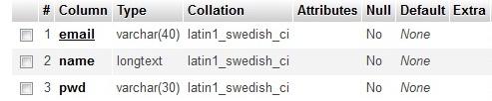
customer

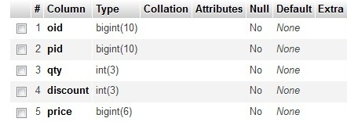
order

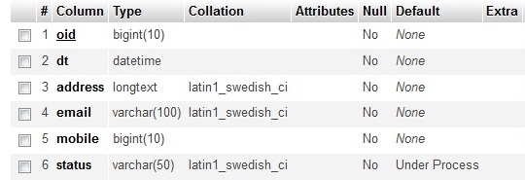
orderdeliverydtls

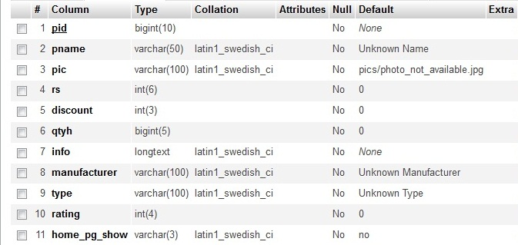
product

Table customer{email is the primary key}
- email, name, pwd defines Email address, Customer name, Password correspondingly.
Table order{no primary key}
- oid= Order ID
- pid= Ordered Product ID
- qty= Ordered Product Quantity
- discount= Discount on the Ordered Product
- price= Total Price corresponding to each item
Table orderdeliverydtls{oid is primary key}
- oid= Order ID
- dt=Ordered date
- address=Delivery Address
- email=Email address
- mobile=Customer's mobile number
- status=Present status of the order.
Table product{pid is the primary key}
- pid=Product ID
- pname=Product name
- pic=Picture of the product
- rs= Price of the product
- discount= Discount on the Product
- qtyh=Quantity on hand
- info= Info related to the product
- manufacturer= Manufacturer of the product
- type=Type of the product
- rating= User rating for the product
- home_pg_show=Whether this product is to be shown on the home page or not(maximum 4 product can be shown on the home page under each category.)

Different pages of the site –

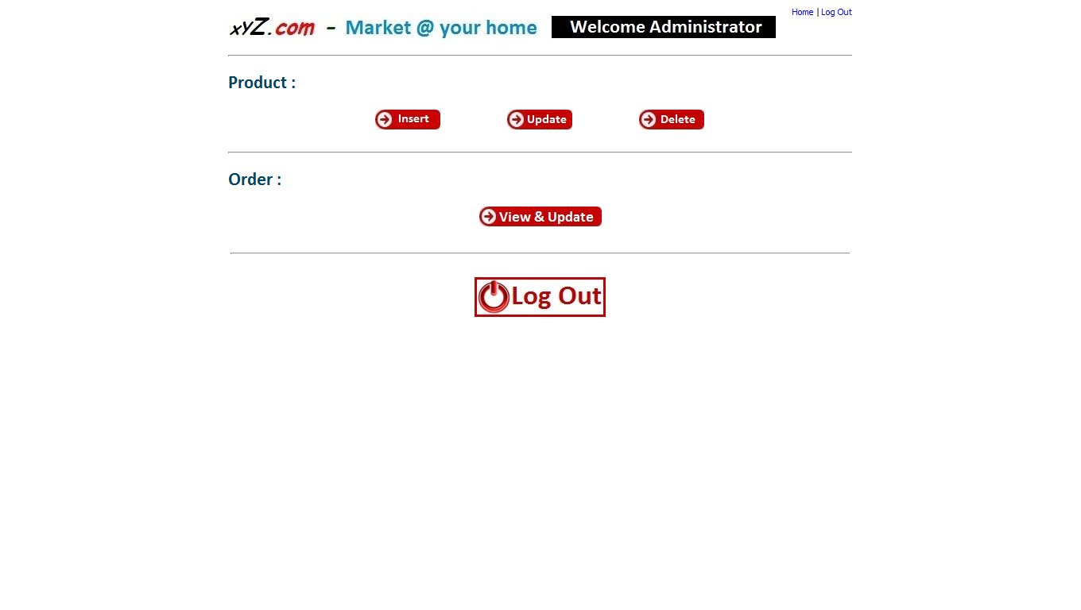
Administrator - Home Page
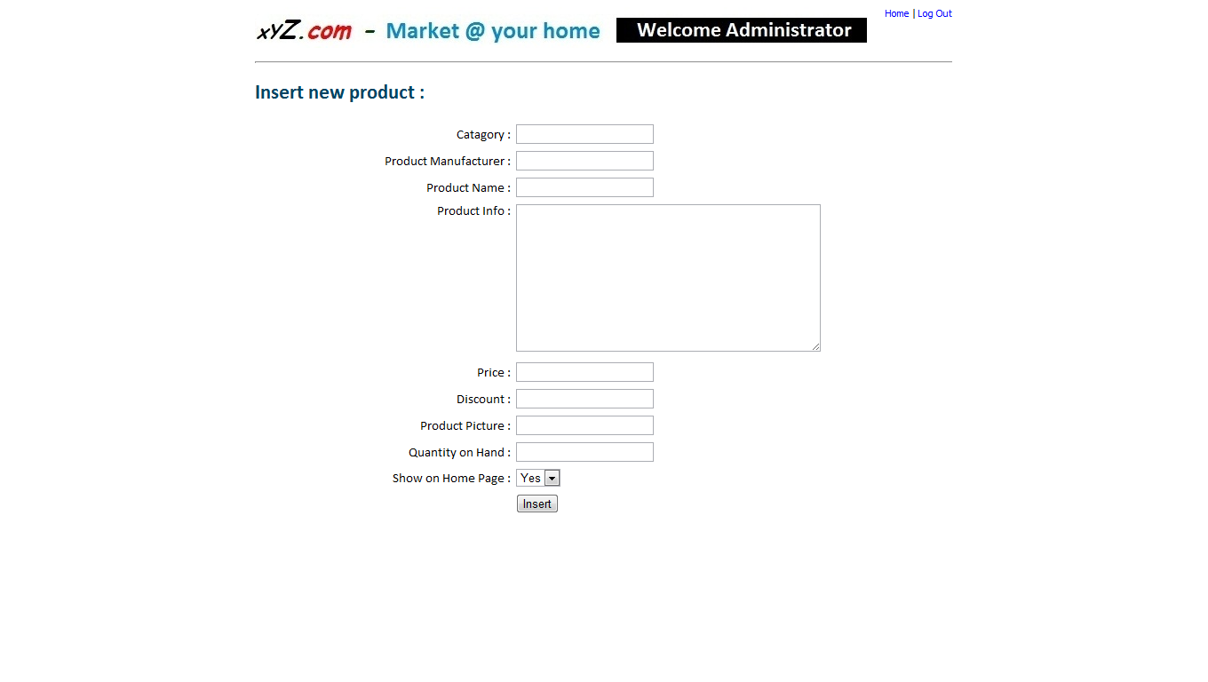
Administrator - Insert new product
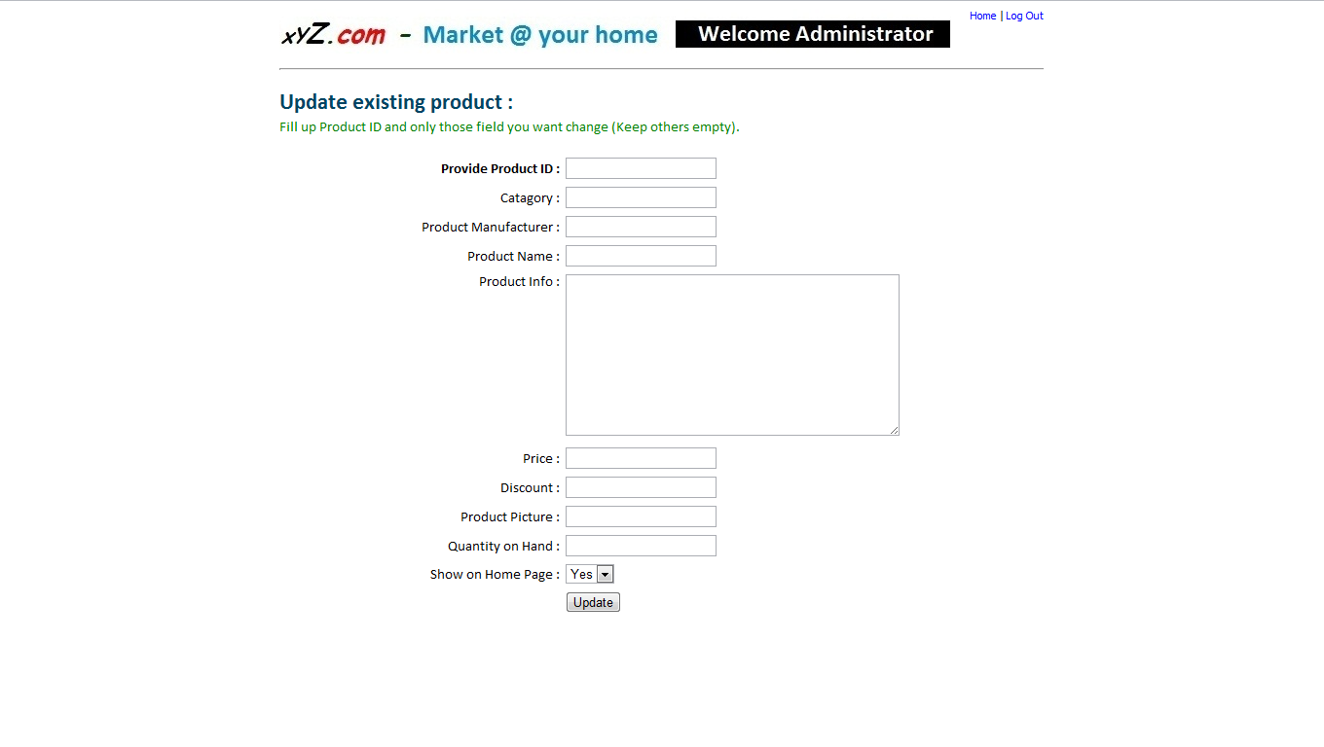
Update Existing Product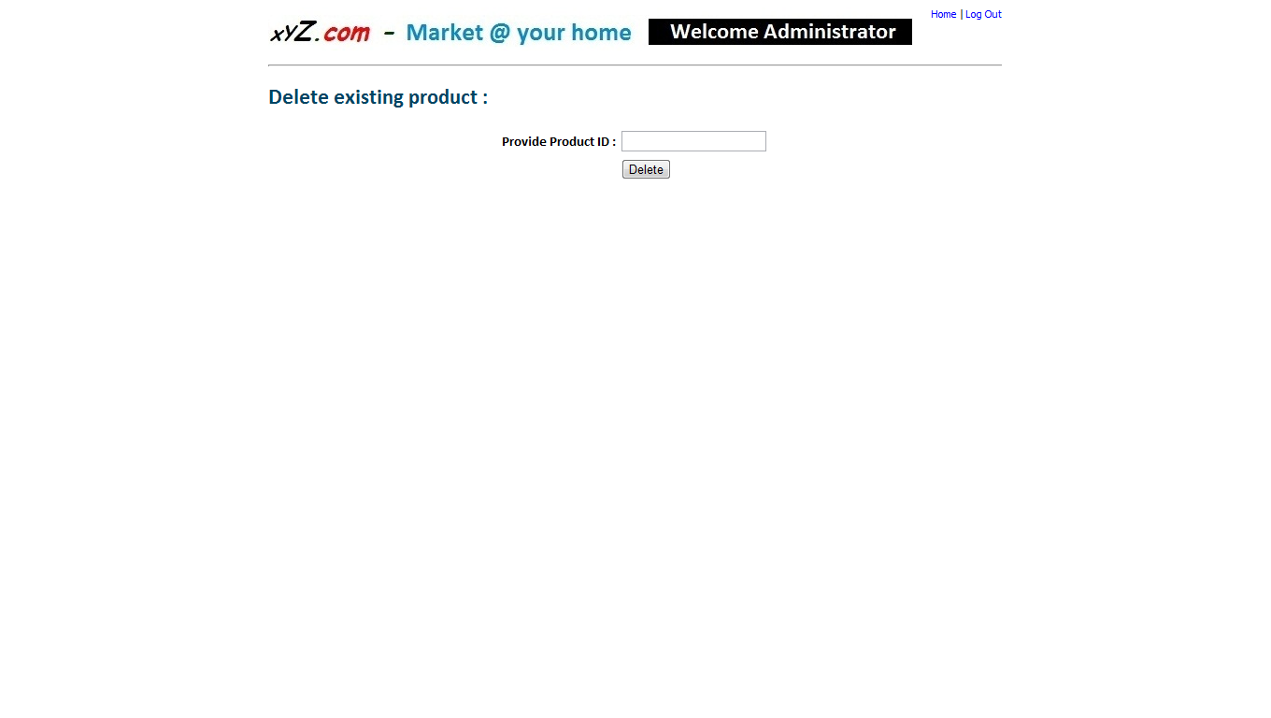
Delete Particular Product

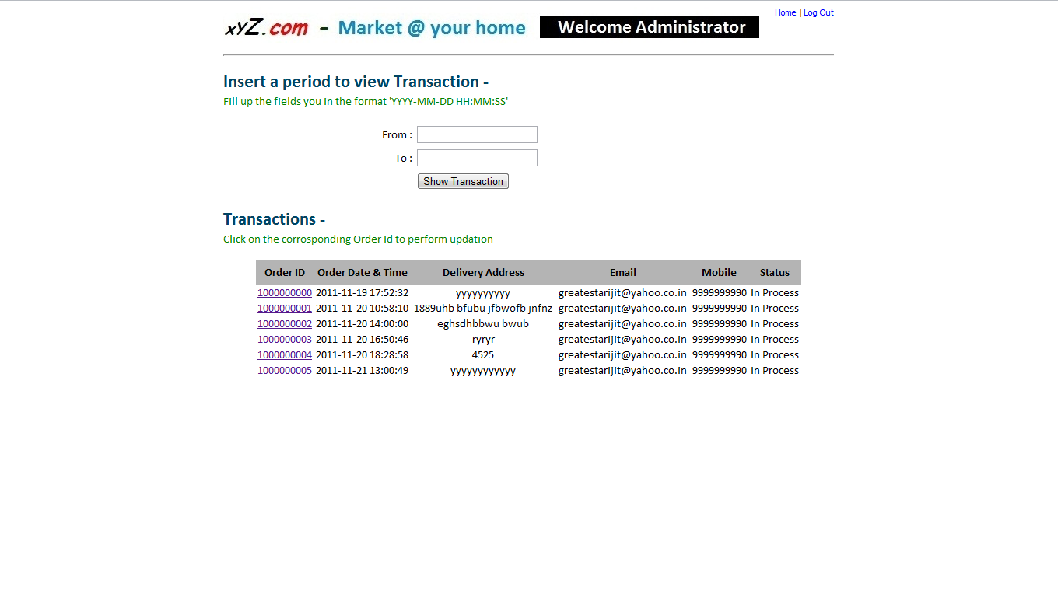
Administrator - View Transactions
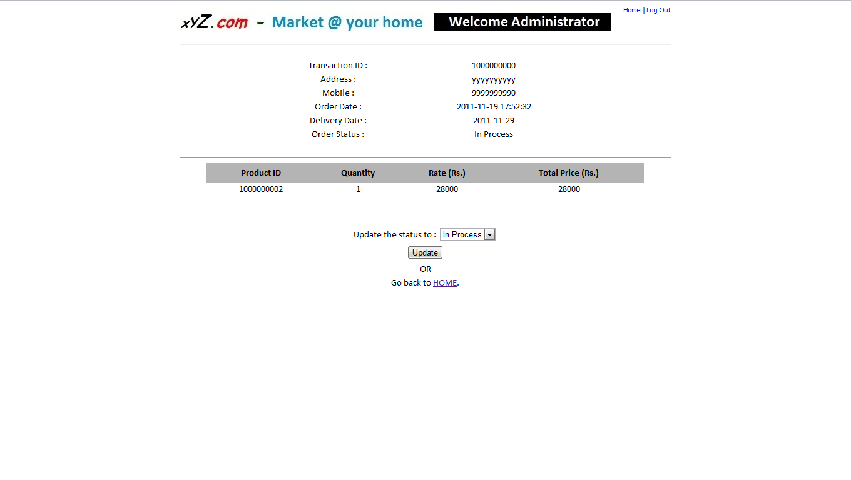
Administrator - Update Transaction Status

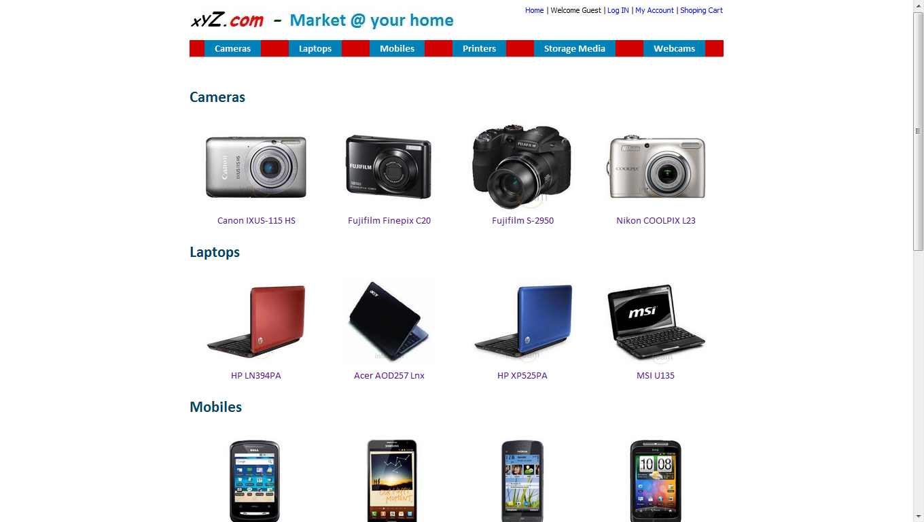

Site’s Home Page
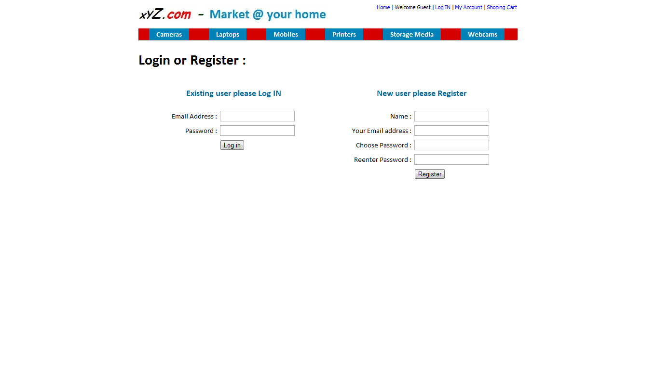
Login
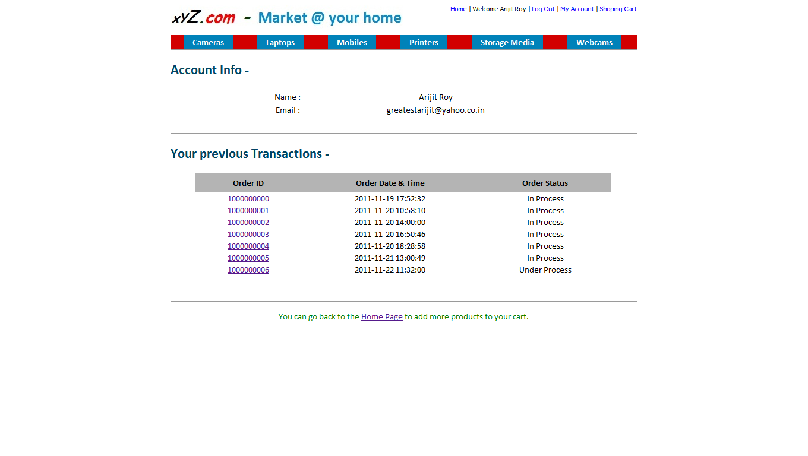
User Account

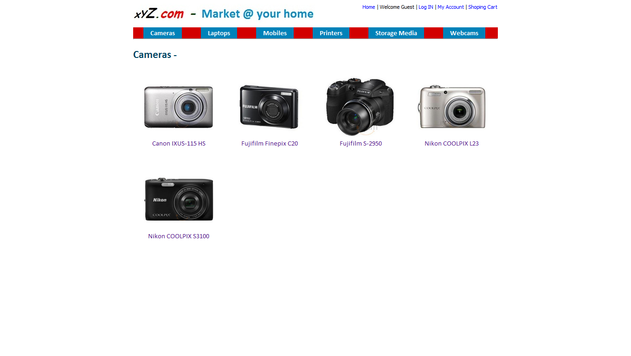
Product Gallery
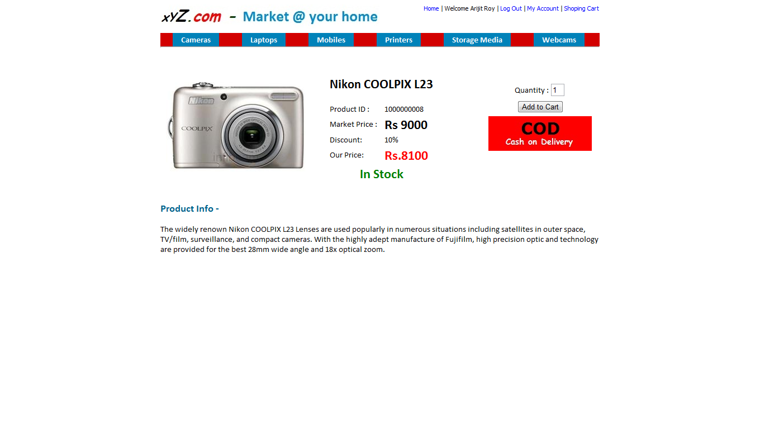
Product Page

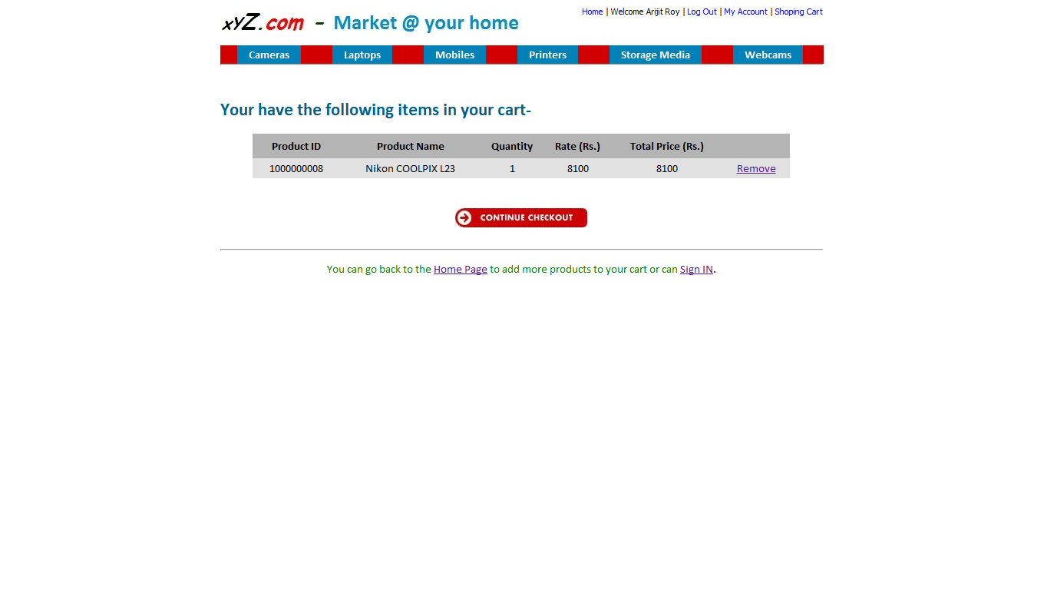
Shopping Cart
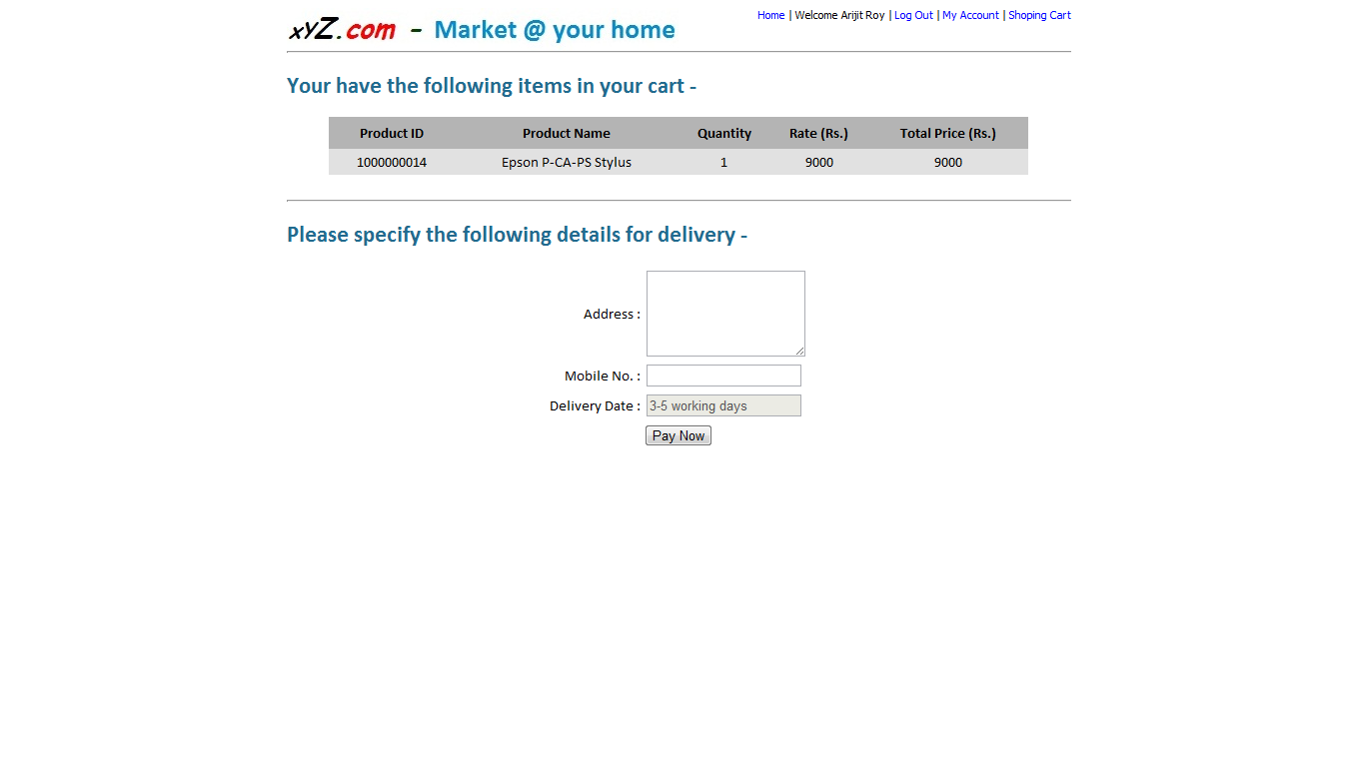
Specify Delivery Details
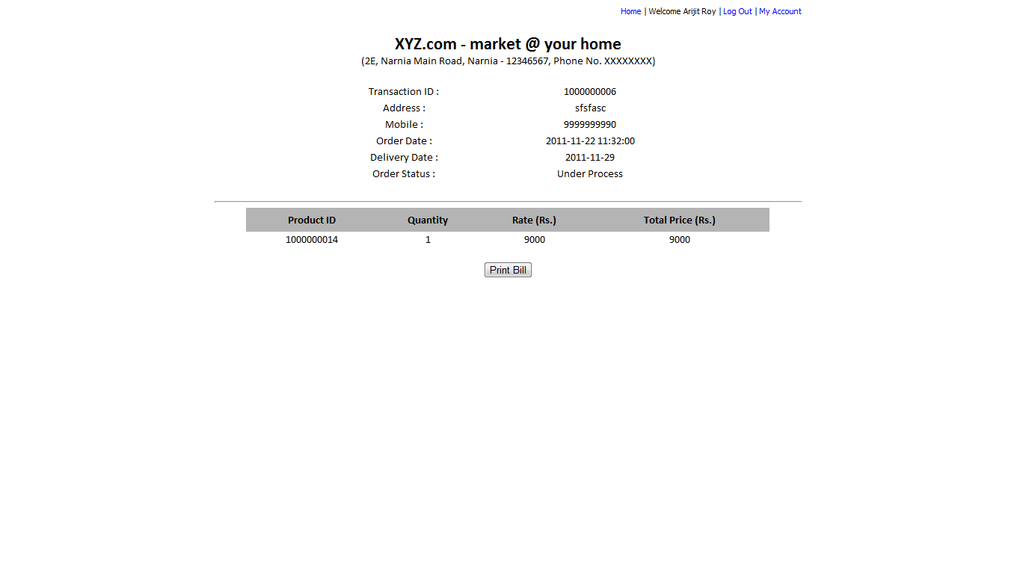
Final Bill Page

